**MODULE: 2 (CSS and CSS 3)**

**1.What are the benefits of using CSS?**

**Ans.** CSS has many advantages.

1) Compatibility can be brought across devices.

2) Simple formatting changes can be made.

3) Fast development saves time.

4) Increases better user experience. Not only does CSS make web pages easier on the eye, it also allows for user-friendly formatting.

5) Faster page speed increases. More code means page speed can be slowed down.

**2. What are the disadvantages of CSS?**

**Ans.**

* Creates confusion between web browsers.
* After making changes we need to confirm carefully if it appears.
* CSS that works with one browser doesn't always work with another.
* Creates confusion between web browsers.
* There is a lack of security in it.
* After making changes we need to confirm carefully if it appears.

**3. What is the difference between CSS2 and CSS3?**

**Ans.** In contrast to CSS2, which consisted of a single document, CSS3 has its uniqueness split into many individual modules, making CSS3 much easier to handle. With CSS3, designers can now use a variety of fonts, including those available in Google Fonts and Typecast.

**4**. **Name a few CSS style components**

**Ans.** CSS style elements are: 1) Selector: HTML element name, id name, class name. 2)Property: Works like attribute like font-size, background-color, text-align, color, position, border etc.

**5. What do you understand by CSS opacity?**

**Ans.** The opacity CSS property sets the opacity of an element. Opacity is the degree to which content behind an element is hidden, and is the opposite of transparency.

**6.How can the background color of an element be changed?**

**Ans.** To add background color in HTML, use the CSS background-color property. Set it to the color name or code you want and place it inside a style attribute. Then add this style attribute to an HTML element, like a table, heading, div, or span tag.

**Input:**

<!DOCTYPE html>

<html lang="en">

<head>

    <meta charset="UTF-8">

    <meta http-equiv="X-UA-Compatible" content="IE=edge">

    <meta name="viewport" content="width=device-width, initial-scale=1.0">

    <title>Document</title>

</head>

<body>

    <!--table start  -->

    <table border="1px">

        <colgroup>

            <!-- table css start -->

            <col span="3" style="background-color: red;">

            <!-- table css end -->

        </colgroup>

        <!-- table first Row start -->

        <tr>

            <td>Sr no</td>

            <td>Name</td>

            <td>City</td>

        </tr>

         <!-- table first Row end -->

         <!-- table secound Row start -->

         <tr>

            <td>1</td>

            <td>rahul</td>

            <td>Ahmedabad</td>

        </tr>

         <!-- table secound Row end -->

          <!-- table third Row start -->

        <tr>

            <td>2</td>

            <td>chirag</td>

            <td>Panchmahal</td>

        </tr>

         <!-- table third Row end -->

          <!-- table fourth Row start -->

        <tr>

            <td>3</td>

            <td>monika</td>

            <td>Valsad</td>

        </tr>

         <!-- table fourth Row end -->

    </table>

    <!-- table end -->

</body>

</html>

**Output:**

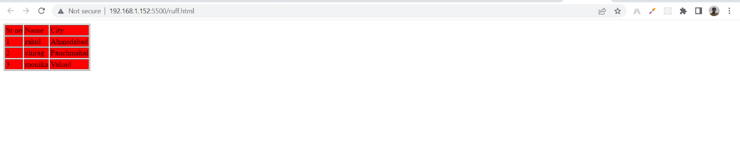

7. **How can image repetition of the backup be controlled?**

**Ans**. The background-repeat property is used to control the repetition of the image in the background. You can use a no-repeat value for the background-repeat property if you don't want an image to repeat, in which case the image will be displayed only once.

**8. What is the use of the background-position property?**

**Ans**. The background-position property sets the initial position of the background image. Tip: By default, a background-image is placed at the top-left corner of the element, and repeats both vertically and horizontally.

**9. Which property controls the image scroll in the background?**

**Ans.**

The background-attachment property sets whether a background image scrolls with the rest of the page, or is fixed.

**Ex.**

**Input:**

<!DOCTYPE html>

<html lang="en">

<head>

    <meta charset="UTF-8">

    <meta http-equiv="X-UA-Compatible" content="IE=edge">

    <meta name="viewport" content="width=device-width, initial-scale=1.0">

    <title>Document</title>

    <!-- backgroung img start -->

    <style>

        .fixed-bg {

          background-image: url("https://thumbs.dreamstime.com/b/environment-earth-day-hands-trees-growing-seedlings-bokeh-green-background-female-hand-holding-tree-nature-field-gra-130247647.jpg");

          min-height: 500px;

          background-attachment: fixed;

          background-position: center;

          background-repeat: no-repeat;

          background-size: cover;

        }

        </style>

        <!-- background img end -->

        </head>

        <body>

        <!-- contant start -->

        <p>In this example, we have created a fixed background image that will disappear slowly on scroll. Scroll the page to see the effect. <strong>Note:</strong> Try to remove the background-attachment property to really understand this example.</p>

        <!-- contant end -->

        <div class="fixed-beg"></div>

        <div style="height:300px;background-color: white;">This div is only here to enable scrolling (height = 50 pixels).</div>

        </body>

        </html>

**Output:**

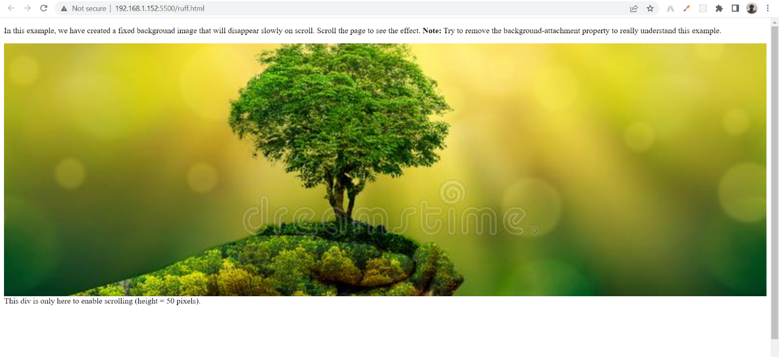

**10. Why should background and color be used as separate properties?**

**Ans**. There are two reasons behind this:

* It enhances the legibility of style sheets. The background property is a complex property in CSS, and if it is combined with color, the complexity will further increase.
* Color is an inherited property while the background is not. So this can make confusion further.

**11. How to center block elements using CSS1?**

**Ans.**

The properties margin-left and margin-right can be set to auto and width to some specified value:

BODY { width: 30em; background: cyan;}

P {width: 22em; margin-left: auto; margin-right: auto }

In this case, the left and right margins will each be four ems wide, since they equally divide the remaining eight ems from (30em - 22em). Note that it is not necessary to set an explicit width for the BODY element; It was done here to keep the math clean.

**Another example:**

table { margin-left : auto ; margin-right: auto; width: 400px;}

In most legacy browsers, the width of a table is determined by default by its content. In CSS-compliant browsers, the full width of any element (including tables) defaults to the full width of its parent element's content area. As browsers become more compatible, authors will need to be aware of the potential impact on their design.

**12. How to maintain the CSS specifications?**

**Ans.** The Specification also include:

The syntax and data types of the language

Detailed explanation on CSS Selectors

How you can assign values to properties

The Cascade (the "C" in CSS)

How inheritance works

The Box Model e.t.c

**13. What are the ways to integrate CSS as a web page?**

**Ans.** CSS can be added to HTML documents in 3 ways:

* Inline - by using the style attribute inside HTML elements.
* Internal - by using a <style> element in the <head> section.

**Ex.**

**Input:**

Inline css

<!DOCTYPE html>

<html lang="en">

<head>

    <meta charset="UTF-8">

    <meta http-equiv="X-UA-Compatible" content="IE=edge">

    <meta name="viewport" content="width=device-width, initial-scale=1.0">

    <title>Document</title>

</head>

<body>

    <!-- inline css start -->

    <p style="background-color: black; color:red">

        <!-- inline css end -->

        <!-- contant start -->

        Lorem ipsum dolor sit amet consectetur adipisicing elit. Nostrum assumenda labore harum porro eum! Dolores libero sapiente repudiandae nemo ducimus, molestias vero beatae, facere accusantium illum, officiis distinctio quos alias.

        <!-- contant end -->

</p>

<!-- inline css start -->

<div style="border: 1px solid black; border-radius:10px; padding: 10px; background-color: aqua;">

    <!-- inline css end -->

    <!-- contant start -->

    Lorem ipsum dolor, sit amet consectetur adipisicing elit. Reprehenderit, sed. Pariatur quod adipisci laboriosam impedit molestias ut, dolore mollitia totam error. Laborum iure laboriosam voluptatum ratione vitae dolor fuga adipisci!

    <!-- contact end -->

</div>

<!-- inline css start -->

<h1 style="background-color: blue;">

Happy navratri &#128512;

</h1>

<!-- inline css end -->

</body>

</html>

**Output:**

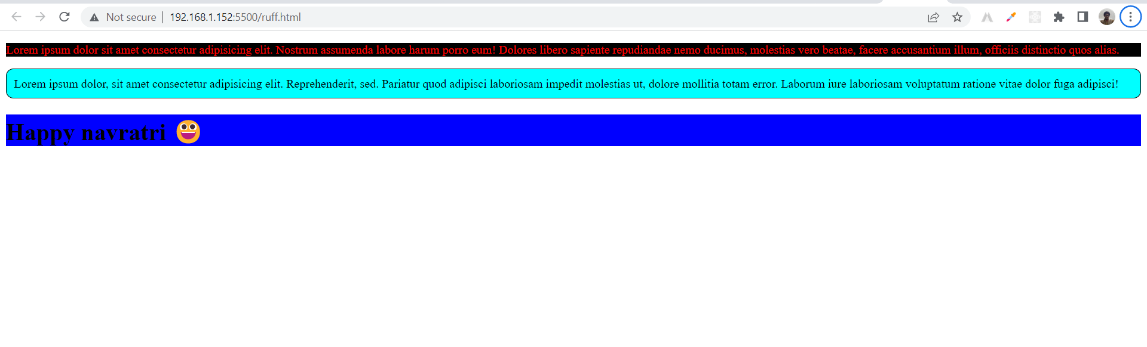

**Internal css**

**Input:**

<!DOCTYPE html>

<html lang="en">

<head>

    <meta charset="UTF-8">

    <meta http-equiv="X-UA-Compatible" content="IE=edge">

    <meta name="viewport" content="width=device-width, initial-scale=1.0">

    <title>Document</title>

    <!-- internal css start -->

    <style>

        p

        {

            background-color:aqua;

            color:darksalmon;

            font-size: 30px;

        }

    </style>

    <!-- internal css end -->

</head>

<body>

    <!-- contant start -->

    <p> Lorem ipsum dolor sit amet consectetur adipisicing elit. Quis quos dolore aperiam molestias fugit velit temporibus voluptatum, hic suscipit pariatur similique sequi perferendis repellat sunt maxime. Eligendi eveniet eius corporis.</p>

    <h1>Happy Navratri &#128514;</h1>

    <!-- contant end -->

</body>

</html>

**Output:**

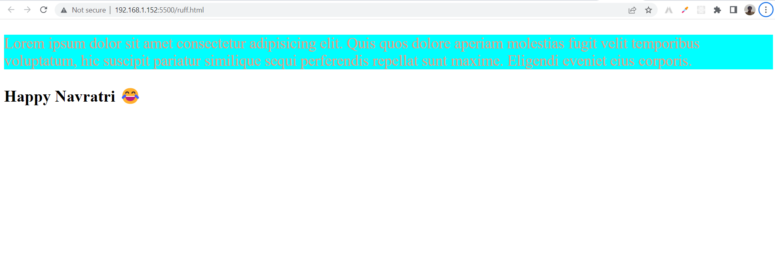

**External css**

**Input:**

<!DOCTYPE html>

<html lang="en">

<head>

    <meta charset="UTF-8">

    <meta http-equiv="X-UA-Compatible" content="IE=edge">

    <meta name="viewport" content="width=device-width, initial-scale=1.0">

    <title>css tutorial</title>

    <link rel="stylesheet" href="style.css">

</head>

<body>

    <!-- Title start -->

    <h2> Lorem insum dolor sit</h2>

    <!-- Title end -->

    <!-- Contant start -->

    <p>Lorem ipsum dolor sit, amet consectetur adipisicing elit. Sequi quibusdam minima placeat molestiae. Laudantium, eius ad laborum incidunt deserunt ratione consectetur ipsam magnam voluptatibus, tenetur, officiis rem vitae soluta aspernatur?</p>

    <!-- Contant end -->

</body>

</html>

**Style.css file**

**Input:**

p{

    /* contant start */

    background-color:rgb(0, 255, 4);

    color:darksalmon;

    font-size: 30px;

    /* contant end */

}

**Output:**

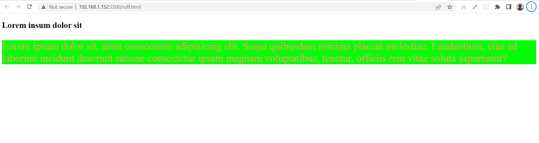

**14. What is embedded style sheets?**

**Ans.** Embedded Stylesheet: It allows you to define styles for a particular HTML document as a whole in one place. This is done by embedding the <style></style> tags containing the CSS properties in the head of your document.

**Input:**

<!DOCTYPE html>

<html lang="en">

<head>

    <meta charset="UTF-8">

    <meta http-equiv="X-UA-Compatible" content="IE=edge">

    <meta name="viewport" content="width=device-width, initial-scale=1.0">

    <title>page title</title>

     <!-- Embedded stylesheet start-->

     <style>

        /* Heading start */

        h2 {

            font-size: 1.5rem;

            color: #2f8d46;

            text-align: center;

        }

        /* Heading end */

        /* Contant start */

        p {

            font-variant: italic;

        }

        /* Contant end */

    </style>

     <!-- Embedded stylesheet end-->

</head>

<body>

    <!-- Heading start -->

    <h2>WELCOME TO YMCA CLUB</h2>

    <!-- Heading end -->

    <!-- Contant start -->

    <p>This document is using an embedded stylesheet!</p>

    <p>This is a paragraph</p>

    <p>This is another paragraph</p>

    <!-- Contant end -->

</body>

</html>

**Output:**

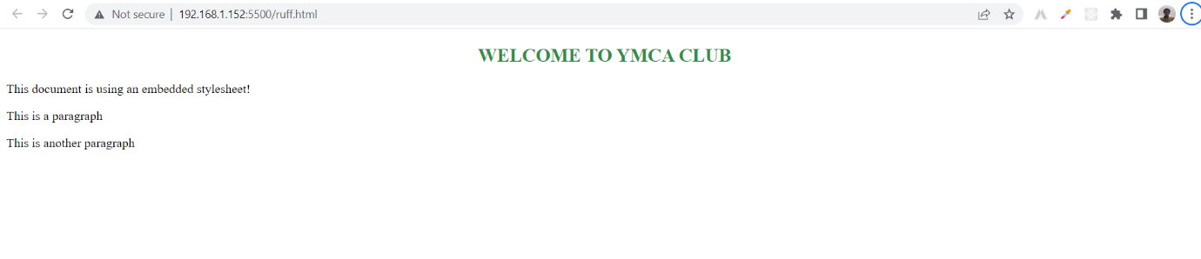

**15. What are the external style sheets?**

**Ans**. An external style sheet is a separate CSS file that can be accessed by creating a link within the head section of the webpage. Multiple webpages can use the same link to access the stylesheet. The link to an external style sheet is placed within the head section of the page.

**EX.**

**Input:**

<!DOCTYPE html>

<html lang="en">

<head>

    <meta charset="UTF-8">

    <meta http-equiv="X-UA-Compatible" content="IE=edge">

    <meta name="viewport" content="width=device-width, initial-scale=1.0">

    <title>css tutorial</title>

    <link rel="stylesheet" href="style.css">

</head>

<body>

    <!-- Heading start -->

    <h2> Lorem insum dolor sit</h2>

    <!-- Heading end -->

    <!-- contant start -->

    <p>Lorem ipsum dolor sit, amet consectetur adipisicing elit. Sequi quibusdam minima placeat molestiae. Laudantium, eius ad laborum incidunt deserunt ratione consectetur ipsam magnam voluptatibus, tenetur, officiis rem vitae soluta aspernatur?</p>

    <!-- Contant end -->

</body>

</html>

<!-- Heading start -->

<h1>External File</h1>

<!-- Heading start -->

External stylesheet

p{

    background-color:rgb(0, 255, 4);

    color:darksalmon;

    font-size: 30px;

}

**Output:**

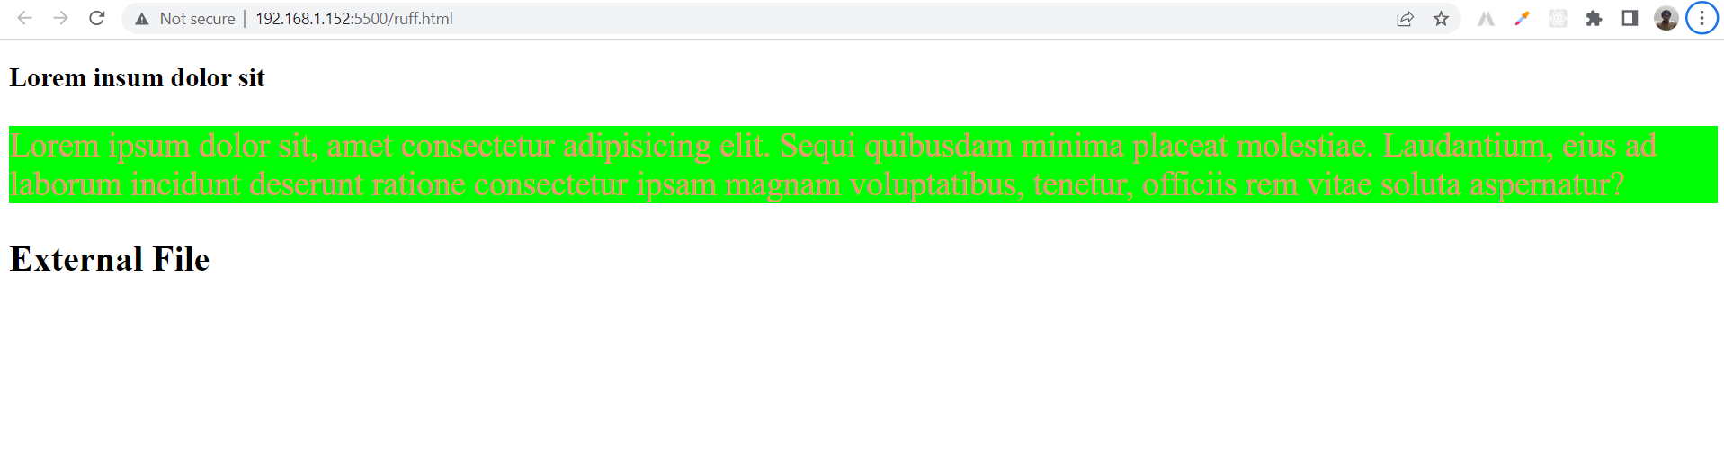

**16.What are the advantages and disadvantages of using external style sheets?**

**Ans. External style sheets have the following advantages over internal and inline styles:**

* one change to the style sheet will change all linked pages.
* you can create classes of styles that can then be used on many different HTML elements.
* consistent look and feel across multiple web pages.

**17. What is the meaning of the CSS selector?**

**Ans.** A CSS selector is the first part of a CSS rule. It is combined with elements and other word patterns. which indicates to the browser which HTML elements are selected to have CSS property values applied to them.

**18. What are the media types allowed by CSS?**

**Ans.** CSS 2. defines the following media groups:

* grid (for character grid devices), or bitmap.
* visual, auditory, speech, or tactile. interactive (for devices that allow user interaction), or static (for those that do not).
* All (includes all media types)
* Continuous or paginated.

**19. What is the rule set?**

**Ans.** To store rules or signatures against which network traffic or system activity is compared to determine actions - such as forwarding or rejecting a packet, generating an alert, or allowing a system event.

**20. Create Layouts**

**Ans.** A website is often divided into headers, me

**HEADER**

**Navigation**

**Section**

**Section**

**Main section**

There are tons of different layout designs to choose from. However, The structure above, is one of the most common, and we will take a closer look at

it in tutorial.

**Footer**